Joseph Ayo

Module 2.3 Assignment – CSD 310

ERD:

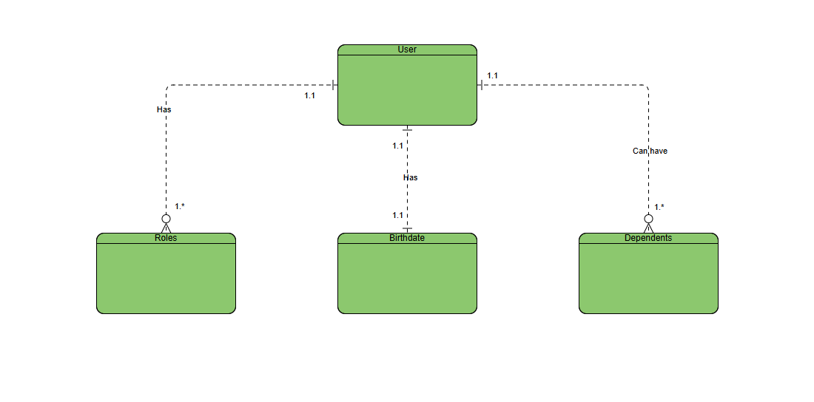

NoSQL:

